**ALDBURY PARISH COUNCIL** WARDENS UPDATE: **JUNE 2025**

|  |  |
| --- | --- |
| **AREA** | **ALLOTMENTS & MILLENNIUM ORCHARD** |
| **TO CHECK** | Fencing & gates, benches, trees, hedges & shrubs, grass height, signs, footpaths, housekeeping, ground conditions |
| **INSPECTION DATES** | 30/5,06/6, 13/6, 20/6, 27/6 |
| **ISSUES TO REPORT** | 1. Public footpaths were in good condition and well defined within the orchard. 2. Most allotment plot holders are maintaining their plots to a good standard. Some instances may require additional housekeeping. 3. Fences, gates, and benches were in fair condition. 4. Information signs were in situ and legible. 5. The grass height meets the mowing specification. The pathways and play area were mown three times this month. 6. Tree Branches and overgrown vegetation is making vehicular movement problematic at the allotments (upper boundary). APC may wish to address this matter in the autumn.   **Outstanding items**   * A new waymarker is required for public footpath no: 6. |

|  |  |
| --- | --- |
| **AREA** | **PLAYGROUNDS** |
| **TO CHECK** | Equipment, Safety Information, Fencing & Gates, Benches, Trees, Grass height, General ground conditions, Empty litter bin. |
| **INSPECTION DATES** | 30/5,06/6, 13/6, 20/6, 27/6  Tring Station 25/06 |
| **ISSUES TO REPORT** | 1. Both playgrounds were visually checked and remain in good condition. The following can be confirmed:  * Both playgrounds display clear and legible user and ownership information. * The grass at Aldbury Playground was cut three times this month and at Tring Station it was cut on two occasions. Grass height is meeting the mowing specification. * Benches are in fair condition, and gates were operational. * The litter bin was emptied weekly. * The rubber safety surface around the Carousel – Roundabout is worn in several places (noted in the ROSPA report). Designated as Low risk but needs to be monitored for further deterioration (Photo 1).   **Outstanding Items**   * A decayed fence/gatepost at the Aldbury playground, along with attached fence panel, is unsteady. APC is consulting with a local contractor to fix this issue. * Update playground signage to meet best practice standards. * Gaps between the rubber tiles in the swing area need closing to prevent trip hazards. |

|  |  |
| --- | --- |
| **AREA** | **RECREATION GROUND** |
| **TO CHECK** | Tennis court, Basketball area, Pavilion, Fencing, Benches/seats, Bollards, Trees & vegetation, Grass height, car park, Litter & dog waste bins, Footpaths. |
| **INSPECTION DATES** | 30/5,06/6, 13/6, 20/6, 27/6 |
| **ISSUES TO REPORT** | 1. Grass height is meeting the specification and was mown three times this month. A good standard is being maintained. 2. Weekly litter picks were conducted. Litter and dog waste bins were emptied on a weekly basis by DBC. 3. Benches were seen in fair condition. 4. The tennis court was seen in good order. However, APC my wish to consider the following:  * Ant infestation has caused a small hole to open on the tennis court surface (Photo 2). * The tennis court net needs repair/replacement being threadbare in places (Photo 3).  1. No new defects were seen on the trees. The last tree survey was conducted in July 2023. 2. Tree branches growing over the basketball area have been successfully cut back.   **Outstanding items**   * A dead tree is leaning against another tree and needs to be removed. The clerk is organizing its removal. * The entrance to the car park requires surface and pothole repairs. * Graffiti removal is required from the sports pavilion wall to deter additional occurrences. * A public footpath sign needs to be reinstated (public footpath no: 27). |

|  |  |
| --- | --- |
| **AREA** | **VILLAGE GREEN(S) & POND** |
| **TO CHECK** | Benches, Trees, Pond, Grass height, Stocks, Litter Bins, Notice board. |
| **INSPECTION DATES** | 30/5,06/6, 13/6, 20/6, 27/6 |
| **ISSUES TO REPORT** | 1. The benches were observed in good condition. 2. No visible defects were observed on the trees. Some dead wood noted lying on the ground. 3. The grass areas were mowed three times this month. A well-maintained and orderly appearance continues to be upheld. 4. DBC emptied the litter bins on a weekly basis. 5. Weekly litter picking was conducted. Low level of litter. 6. The notice board was well-maintained. Information displayed was current and relevant. 7. A wooden post has been knocked over by a motor vehicle and needs reinstating (Photo 4). |

|  |  |
| --- | --- |
| **AREA** | **HIGHWAY’S, PUBLIC FOOTPATHS & DITCHES** |
| **TO CHECK** | Surfaces, Pedestrian routes, Signage, Drainage, Grit bins, Litter, Street lamps, Bollards, kissing gates, Notice board (Tring Station) |
| **INSPECTION DATES** | 30/5,06/6, 13/6, 20/6, 27/6 |
|  |  |
| **ISSUES TO REPORT** | 1. Overgrown hedges in Station Road between Clarkes Spring and the railway station were cut back from the pathway by HCC. Ref No: 401004669536. 2. A visual check of the streetlights was conducted on the 30th of June. No additional defects were identified to be added to the existing list of outstanding items below. 3. Litter picking was conducted along Stocks Road (to the parish boundary), New Ground Road (to the GUC bridge), Malting Lane, Stonycroft and Toms Hill to FP15. 4. The drainage ditch south of Stonycroft appears clear, but dense summer vegetation hinders a close inspection. 5. HCC have repaired two potholes in New Ground Road. Ref No’s 401004677655 and 401004677656 (Photos 5 & 6). 6. A new notice board has been installed in Tring Station (Photo 7).   **Outstanding Items**   * Reinstatement of waymarker in Hitchins Field (public footpath no:63). * Replacement of a decayed street nameplate on Toms Hill. This has been added to DBC replacement list. Ref No: 895084. * Restore streetlighting at the Recreation Ground entrance, opposite the Church, Malting Lane junction, and near Beechwood Drive junction. * Two faded SLOW road marking on Toms Hill and station Road to be repainted, HCC Ref No’s: 401004654989 and 401004654999. * Overgrown shrubbery in Trooper Road is yet to be cut back by a resident, despite receiving an APC advisory letter. |

**PHOTOGRAPHS**



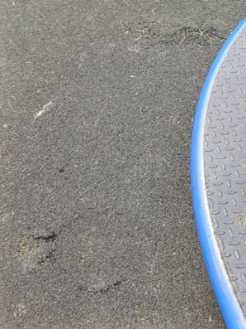 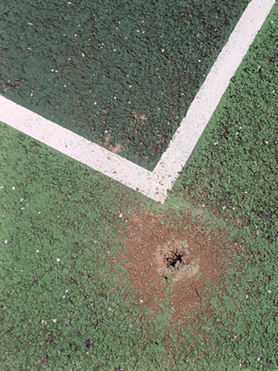

3

1

2

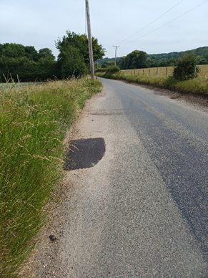 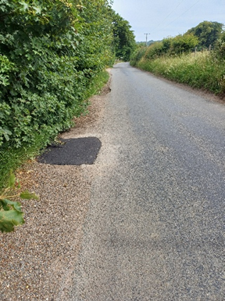

6

5

4

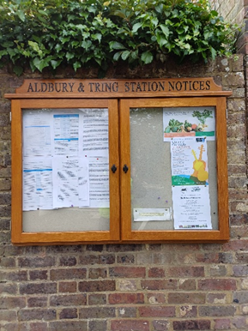

7